Lab:

**Web application configuration API - POST a web application**

This **lab lets you create a new Web Application configuration** in Dynatrace **via the API**.

Instead of going to the UI and clicking "Add web application," you can **automate it** using a POST request to this endpoint.

Setup postman on windows

<https://www.postman.com/downloads/>

1. Go to web page

<https://docs.dynatrace.com/docs/discover-dynatrace/references/dynatrace-api/configuration-api/rum/web-application-configuration-api/web-application/post-web-application>

Check for post request syntax

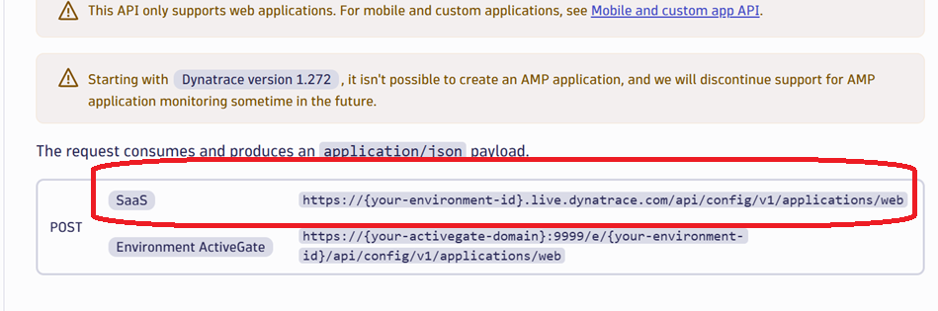

1. In postman select event type, post

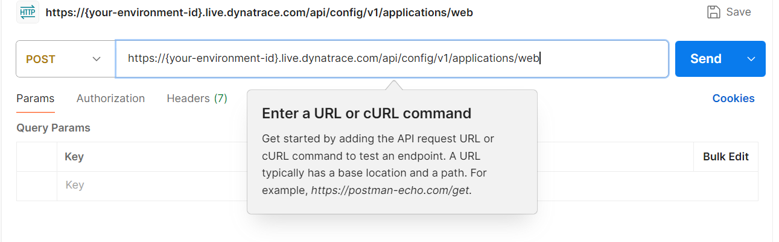

Change your environment id

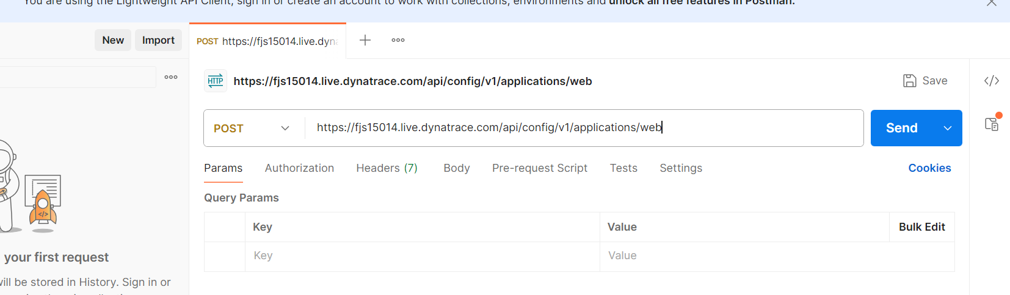

Click on Body

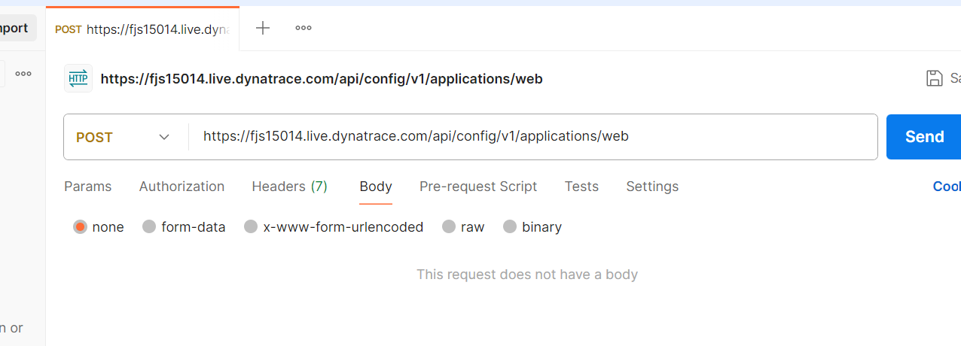

Json body

<https://docs.dynatrace.com/docs/discover-dynatrace/references/dynatrace-api/configuration-api/rum/web-application-configuration-api/web-application/post-web-application>

Change the application name and url

Application name : myuitest

url: <https://www.openwriteup.com/>

Select raw in postman and paste the json[ modify url pattern and application name

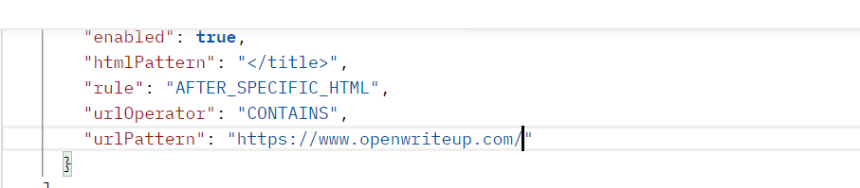

->

In postman authorization: select the type of authorization ->apikey

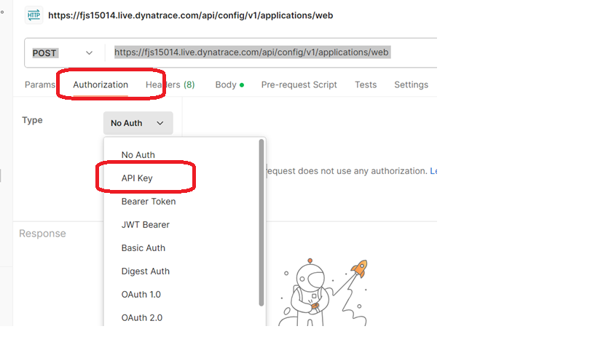

Go to Dynatrace homepage

Apps->access token -> generate token

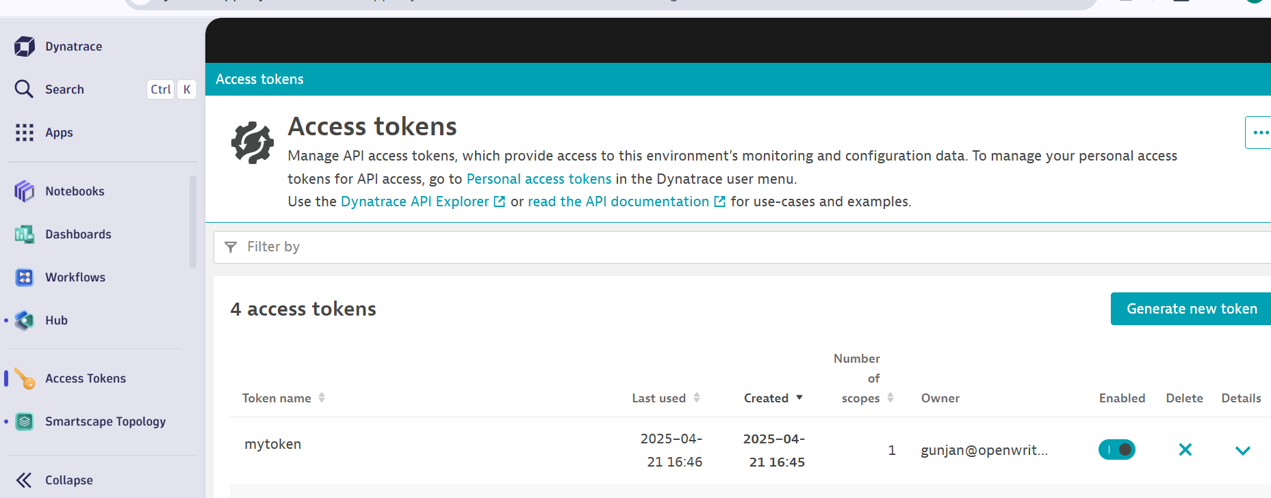

Scope : Write configuration

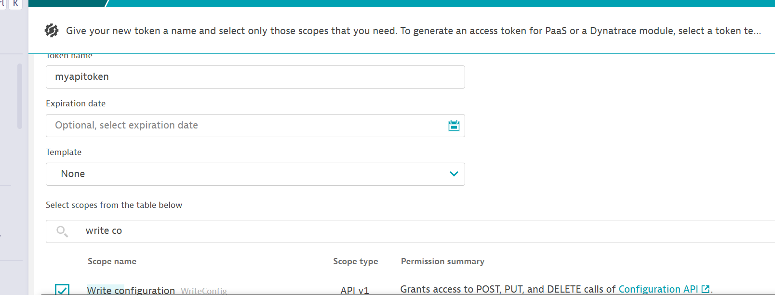

Copy the token

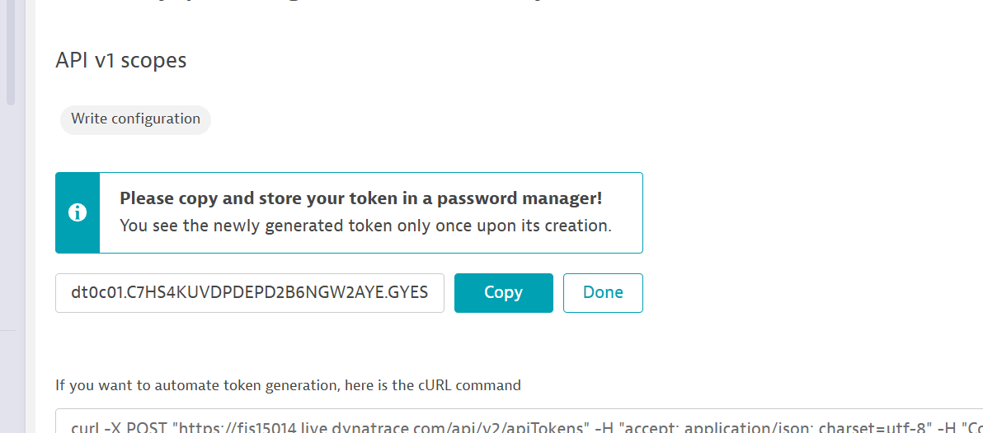

Navigate back to postman

Provide

Key: Api-Token

Value: Paste token from above one

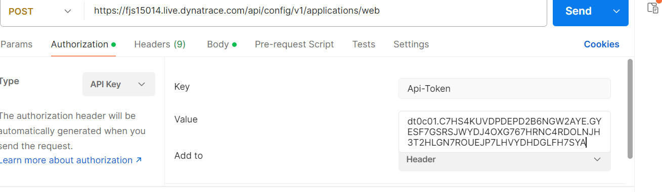

And set the query params

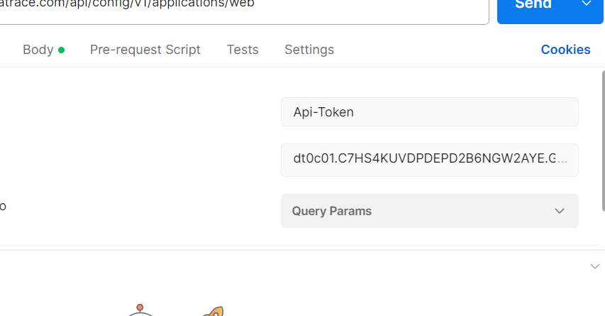

Click on send

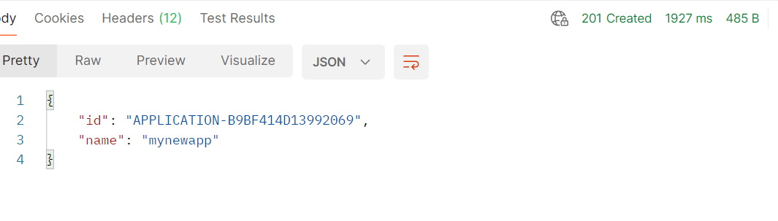

Go to Dynatrace and check for app🡪custom application

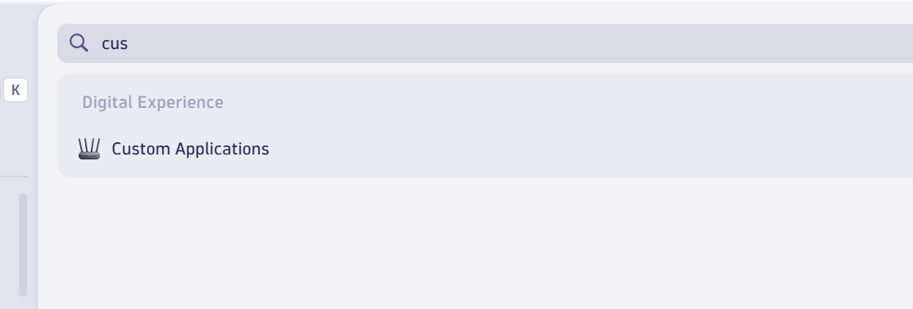

Click on monitoring setting

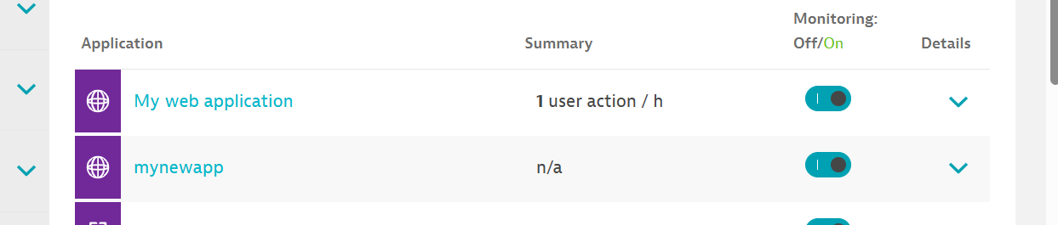

Click on app

